***Lab 13- Custom Filter Demo***

***In this example we shall implement Custom Action Filter and Custom Exception Filter. For this we need to implement ActionFilterAttribute abstract class and IExceptionFilter interface.***

*Create a new MVC Application:*

*File > New > Project > Project Name: “Lab 13-CustomFilter” > Empty > OK*

*Add a HomeController*

*Right click on Controller Folder > Add > Controller > HomeController > OK*

*Now add the following two action methods in the HomeController:*

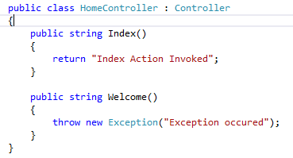

*Now we shall implement the Filter:*

*Right click on the solution > Add > New Folder > name it as “Filters”.*

*Right click on the Filters folder > Add > Class > name = “TrackExecutionTime.cs”*

*Inherit* ***ActionFilterAttribute*** *and* ***IExceptionFilter*** *> Implement all the methods of the abstract class and interface as shown below:*

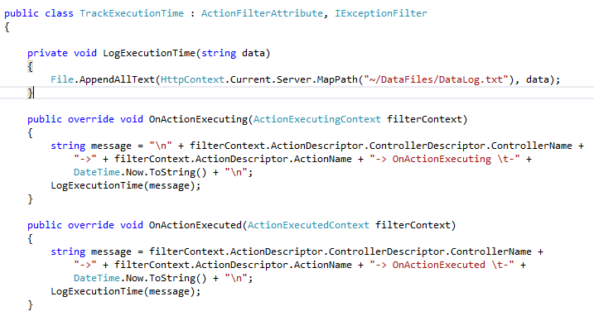

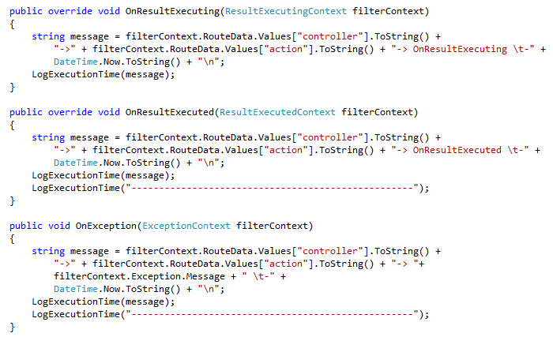

*Right click on the solution > Add > New Folder > name it as “DataFiles”.*

*Right click on the Filters folder > Add > TextFile > name = “DataLog.txt”*

*Now add the attribute name in the HomeController.cs*

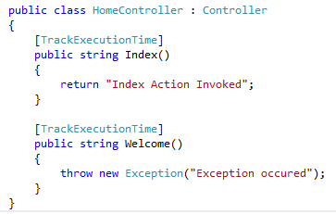

*Now when the code is executed using the both the following URLs:*

**

**

*Now the text file will have the following code:*

